# Challenge 2

Leant baics of docker for this question and had no idea about what docker is previously. Managed to successfully solve this question.

## Approach for Backup

I wen to chatgpt to provide it with relevant prompts to help me create a backup. It did provide me with a python code which could list all the volumes that I had In my system but could not locate the path of where the data of those volumes it stored. So I did my own digging on the web to find the path where all the docker data is stored. I found a folder containing folders with name of volumes and within those folders was the data of that docker volume.

Now the question was straight forward that I just had to copy those folders to a secure folder called backup.

Proposed directory structure-

* Backup
  + Volume1
    - Checkpoint1 (with timestamp)
    - Checkpoint2 (with timestamp)
  + Volume2
    - Checkpoint1 (with timestamp)
    - Checkpoint2 (with timestamp)

I made a python script that would create a folder called Backup which would contain subfolders with the name of volumes and these respective folders would contain the zipped files of all the data of that volume with timestamp to identify the most latest backup at the time of restoration.

Below is the log output we get upon running the backup script.

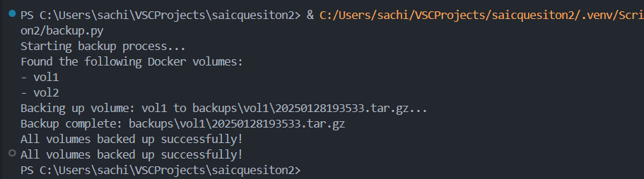

## Approach for Restore

Restoring approach was also pretty straight forward since all I had to do was to ask the user which volume he wanted to restore the backup for and then tap into the backup folder and the subfolder where the zipped data for that volume is located and then extract that file and put it in the main path where data for all volumes is kept. I also asked the user which checkpoint it to be restored and provided a default option to restore the most latest checkpoint created.

Below is the output we get on running the restore script.

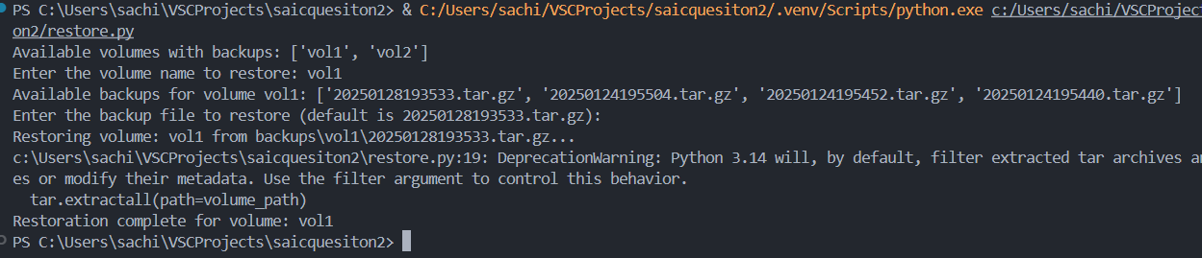

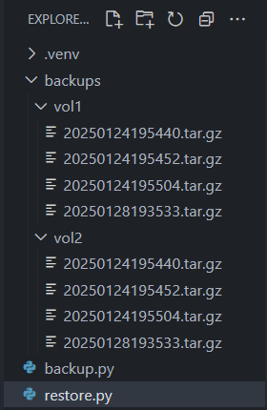Below is file structure created by the backup script:

#### Instructions to run the scripts

These are 2 python files which can be executed through cmd. Just copy both scripts and .venv folder which is a virtual environment containing all required libraries for the script. Then open cmd and navigate to that folder. Activate the env by the command

.venv\Scripts\activate

And then run the required python file by

python {file name}

make sure that this procedure needs python to be installed in windows. Alternatively, .py can be convert to .exe file

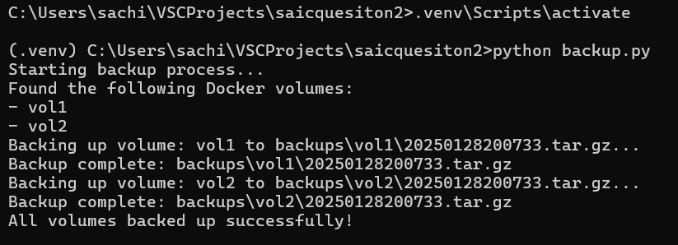

#### Instructions of Testing functionality with sample docker setup

Create sample volumes by the command {docker volume create vol1} then add some random data to the volume and then you can run the scripts to backup the data.

#### Instruction to setup Cron Job

Cron job is Linus based. However, it can be replicated in windows by Task Scheduler. We can create a .bat file triggering the backup.py at the location. Then we go to Task Scheduler, create a new task and select Run at highest privileges then we can schedule it to run daily at 12 am and hit ok and then select this bat file to ne triggered at 12am and thus this will automate the backup to run everyday at 12am